Karate – Do – Shotokai . France

Ecole de Maître Mitsusuke HARADA

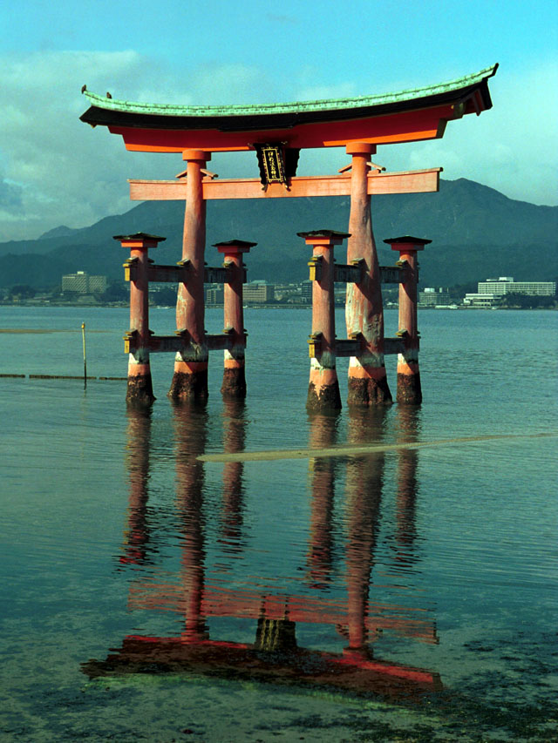

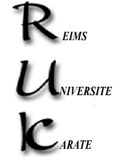

48th year
Spring is coming, together with our traditional Reims course. Even if Bo/Jo and sword will be mentioned, this time our practice will focus on Karate itself: understanding the use of the body and its transposition in katas.
The course will be run under the guidance of :

Gladys & Bernard M.

Practices will take place at the following sites:

* Friday 17th - 20:00 / 22:00 - Salle de danse, Halle de Sport universitaire –Croix Rouge district – Avenue François Mauriac - Complexe sportif Géo André).
* Saturday 18th – 10:00 /12:00 and 15:00 / 18:00
GU Moulin de la Housse – Science faculty Campus – Route de Châlons
* Sunday 19th – 10:00 / 13:00 - Same place.

Fees : none
We will organize a meal on the Saturday night – Let us know asap if you intend to join.
e-mail: gbmathieu@gmail.com Site internet: www.reims.kds-france.fr
gladys.cebrand@gmail.com Tel: +33 6.62.11.58.58.

